MEDIA CONTACTS
Connie Shaver 612.308.5785
connieshaver@charter.net
Doug Little 612 .871.3534
doug@douglittlemusic.com

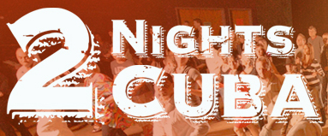

Charanga Tropical announces a Kickstarter campaign to play at summer music festival in Havana, Cuba! Fundraising shows at Bedlam Theater, Cedar Cultural Center
Featuring guest artists from Malamanya, Salsa Del Soul,
Salsabrosa, QBand, and Nachito Herrera!

PLUS announcing opportunity to travel to Cuba with Charanga
this summer on specially licensed People-To-People trip!

Minneapolis, Feb. 14, 2015 -- In another sign of warming ties between the United States and Cuba, Minnesota's own Charanga Tropical has been invited to perform at the 2015 International Festival of Danzón in Havana June 24 to 28, 2015. The Twin Cities-based band is the first North American ensemble ever invited to participate in the festival, which will include multiple performances celebrating the rich musical style of danzón. Unable to receive direct compensation from the festival due to the still active United States economic embargo, Charanga Tropical will instead crowd fund its Cuba tour, which will result a CD recorded live in concert in Havana. The 60-day Kickstarter campaign will launch February 19 and run through April 19.
Mid-campaign, March 13 & 14, Charanga Tropical will present a two tremendous shows with an array of special guests. On Friday, March 13 at Bedlam Theatre and Saturday, March 14 at The Cedar Cultural Center, Charanga Tropical will be joined by Cuban pianists Nachito Herrera and Viviana Pintado, singers Juan Castro and Franklin Paz from Chicago, and musicians from top local Latin groups such as Malamanya, Salsa Del Soul, and Salsabrosa. There will be dance showcases by pros from Rene Dance Studio and Social Dance Studio and intricate routines by salsa performance teams Minniami Salsa and Salsa De La Calle. Two Nights To Cuba promises to be the biggest and most joy-filled Latin music and dance collaborations of the year.
Doors at both venues open at 8 p.m. with DJ Momchil spinning salsa hits. Bring your dancing shoes for a lively salsa lesson from one of Minnesota's leading instructors Rene Thompson, former lead dancer at La Tropicana in Havana, Cuba. Tickets are $15 in advance and $20 at the door.
Additionally, Latin music fans can actually travel to Cuba in June with Charanga as part of a unique People-To-People program specially offered by Cuba Travel & Tours. The agency has long been active in Cuba and coordinated trips for the American Composers Forum, the San Francisco Opera, and many others. For more information about June 2015 travel visit www.TwoNightsToCuba.com/travel.
Danzón is the national dance of Cuba. The music evolved from contradanza, a style which arrived with 19th century French refugees who were escaping violent revolution in Haiti and Napoleon's sale of the Louisiana territory. The immigrants introduced to the island a classical sensibility and new instruments - piano, violin, and flute. The instruments were eventually combined with bass and Cuban drums to create an instrumentation known as 'charanga francesa' (French charanga), later known simply as 'charanga.'

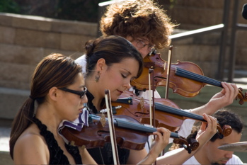
String Section of Charanga Tropical

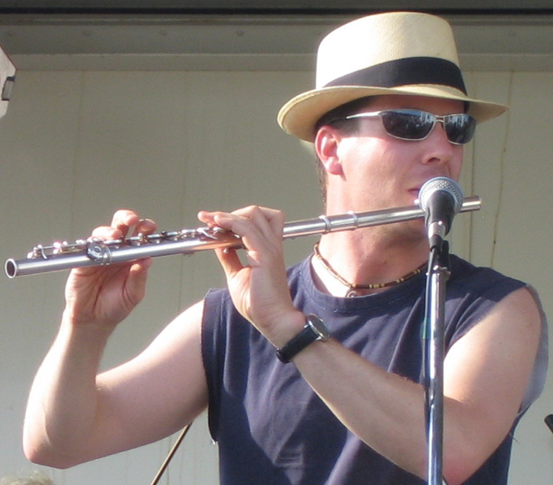
Doug Little

ABOUT CHARANGA TROPICAL
Charanga Tropical features a classic grouping of three violins, flute, and rhythm section. The Minneapolis Star Tribune has acclaimed its “distinct Caribbean sound” while City Pages describes the group as “a musical delight and a visual spectacle.” With an instrumentation that dates back to the roots of Cuban music, Charanga Tropical is one of just a few groups of its kind performing in the United States.
Charanga Tropical was founded in 2006 by longtime jazz saxophonist turned Latin flutist Doug Little. Little traveled to Cuba in 2002 as part of a Jerome Foundation Travel/Study grant. Over the next decade he returned multiple times, spending nearly year in Havana. He learned Spanish, studied with master musicians, and absorbed the culture of Cuba. The repertoire of his band Charanga Tropical features classic danzónes as well as a vibrant mix of modern salsa and original compositions. Charanga has appeared throughout the Upper Midwest including at Minnesota Orchestra's Sommerfest, Duluth's Reggae and World Music Festival, St. Paul's Schubert Club, and Chicago's SummerDance in Grant Park.

CALENDAR EDITORS
Date & Time | Venue | Details | Contact Info
Friday, March 13  8pm to 1 a.m. | Bedlam Theatre  213 East 4th St, St. Paul | $15 in advance  $20 at door | www.2nightsToCuba.com  651-209-0597
Saturday, March 14  8 pm to midnight | Cedar Cultural Center  416 Cedar Avenue Minneapolis | $15 in advance  $20 at door | www.2nightsToCuba.com  612-338-2674
Sunday, March 15  2pm to 3pm | Westminster Church  1200 South Marquette Minneapolis | The Great Hall  Free! | www.2nightsToCuba.com  612-332-3421
For tickets, directions, and complete show information visit www.2NightsToCuba.com
Press kit, high resolution jpegs, and videos, are also available at www.2NightsToCuba.com

# # #

