Doug Little 612 .871.3534
doug@douglittlemusic.com

First American Group EVER Invited To International Danzón Festival
In Havana, Cuba, is Minnesota-Based Band Charanga Tropical!

Invitation being negotiated since 2010, Charanga Tropical is overcoming
Economic Embargo through 30-Day Kickstarter that ends May 1st.
Kickstarter Close-Out Concert April 29th at Landmark Center, St. Paul

Minneapolis, April 13, 2015 - Minnesota's own Charanga Tropical has been invited to the International Danzón Festival in Havana, Cuba, June 24th to 28th, 2015. The Twin Cities-based band is the first North American ensemble EVER invited to the event. As part of the Danzón Festival Charanga Tropical will perform multiple concerts at theaters, nightclubs, and open-air venues throughout the capital city of Havana. Joining the 11-piece Charanga Tropical will be a 4-person support team of recording engineers and photographers documenting the trip. The Cuban concerts by Charanga Tropical will be professionally recorded with the best performances later released on the CD "Charanga Tropical - Live from Havana."
The invitation has been in the works since 2010 and comes directly from festival organizer UNEAC, Cuba's national union of artists, writers, and musicians. The International Danzón Festival will feature Cuba's greatest charanga groups including Orquesta Aragón, Charanga Rubalcaba, and Orquesta Barbieto Diez. All groups will emphasize the great genre of danzón, native to Cuba but known world wide through adaptations by composers such as Aaron Copeland and others.
To commemorate the historic first time participation of an American ensemble, Charanga Tropical will highlight danzón repertoire by Cuban composers from the 1930's and 40's that were inspired by and even quoted popular themes by American composers such as George Gershwin, Harold Arlen, and Cole Porter. The music recalls how close the United States and Cuba once were and how a new era of artistic collaboration and understanding in now upon us.
Due to the long running American economic embargo, Charanga Tropical is unable to receive direct compensation from the festival. Corporate and non-profit donations have been similarly hindered or rendered illegal by the embargo. To overcome this, Charanga Tropical is crowd-funding its project via a 30-day Kickstarter campaign - April 1st to April 30th. The amount needed is $96,000 ($6,400 per participant) for the 11-piece ensemble and 4-person crew of photographers and recording engineers. These funds would cover all transportation, lodging, CD costs, and modest artist compensation. A complete and detailed budget is available at www.kickstarter.com/projects/charanga/tour-to-havana-cuba-festival-shows-and-live-cd-rec
For the tour Charanga Tropical has assembled an all-star lineup featuring Minnesota members as well as band alumni now living in Chicago, New York, Bermuda, and elsewhere. Biographies of all tour participants are available via the Kickstarter Page http://goo.gl/3wCJye.
On April 29th Charanga Tropical will perform a "Kickstarter Close-Out Concert" in the Landmark Center in Saint Paul in the F.K. Weyerhaeuser Auditorium. Show will begin at 7 p.m. and is presented free of charge courtesy of sponsor Wells Piano. Concert attendees will be suggested to make a donation to the Kickstarter campaign as the campaign closes in on its goal.

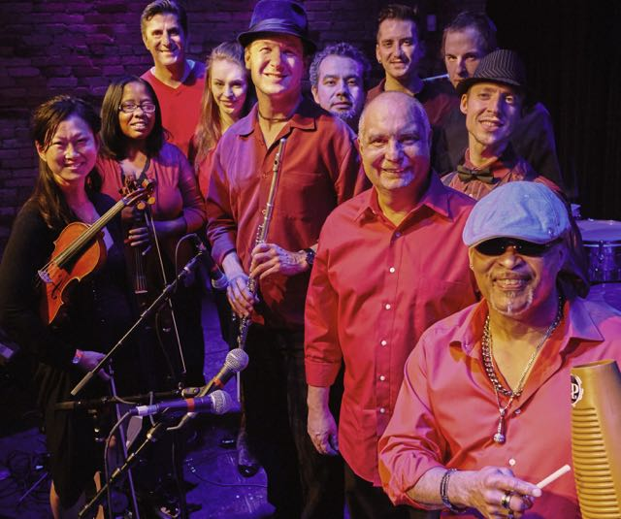
Noteworthy, individuals can travel with Charanga Tropical and attend the Danzón Festival as part of a People-To-People program offered by Cuba Travel & Tours. The agency has been active in Cuba for decades and coordinated trips for the American Composers Forum, the San Francisco Opera, and others. For complete information visit www.charangatropical.com/travel-to-cuba.
ABOUT CHARANGA TROPICAL
Charanga Tropical features the classic charanga instrumentation of flute, three violins, vocalists, and full Latin rhythm section. The group is one of just a few charanga groups performing in the United States. Band repertoire feature classic danzónes as well as a vibrant mix of modern salsa and original compositions. The ensemble has appeared at festivals and other venues throughout the Upper Midwest.
Charanga Tropical was founded in 2006 by longtime jazz saxophonist turned Latin flutist Doug Little. Little traveled to Cuba in 2002 as part of a Jerome Foundation Travel/Study grant. Over the next decade he returned to Cuba multiple times, spending nearly a year apprenticing with master Cuban musicians, composers, and musicologists. For a complete biography of Little and all members of Charanga Tropical visit the Kickstarter Page http://goo.gl/3wCJye

CALENDAR
Date & Time | Venue | Details | Event
Weds, April 29 | F.K. Weyerhaeuser Auditorium Landmark Center  75 West 5th Street, St. Paul | Suggested Kickstarter Donation | Kickstarter Close-Out Concert sponsored by Wells Piano
Saturday, June 13  10:00pm - 12am | Walker Art Center  1750 Hennepin Ave, Mpls | Free! | Northern Spark Festival
Sunday, June 14  5:30pm to 7pm | Lake Harriet Bandshell  4135 W Lake Harriet Pkwy | Free! | Minneapolis Park & Rec
Saturday, June 20 | Orchestra Hall  1111 Nicollet Mall, Mpls | $95-$1,000 | Minnesota Orchestra Symphony Ball / Gala

For tickets, directions, and complete show information visit www.charangatropical.com/schedule
Press kit, high-resolution jpegs, and videos, are also available at www.charangatropical.com/press-kit
###

